SJIB Circular 18/2021
17 December 2021

To: All SJIB and SELECT Members

Dear Sir/Madam,
Queen’s Platinum Jubilee Bank Holiday 2022

To mark 70 years of the Queen’s reign, the UK Government has announced that there will be a bank holiday in June 2022 to mark the Platinum Jubilee, creating an extended weekend from Thursday 2 June to Sunday 5 June.

To accommodate this, the SJIB National Board has decided that the 2022 May Day Holiday will be moved from its usual place on the first Monday in May to Thursday 2 June and that an additional holiday will be granted for Friday 3 June 2022.

Therefore:
- Monday 2 May will be treated as a normal working day.
- Thursday 2 June will be treated as the May Day Holiday for the purposes of Sections D and E of the SJIB National Working Rules. Payment for Thursday 2 June will be in accordance with National Working Rules D5.1 and D8.1.
- Friday 3 June will be an additional bank holiday. Payment for Friday 3 June will be at a flat rate of 7.5 hours.

Operatives required to work on Thursday 2 June shall be paid in accordance with National Working Rule D10.1.

Operatives required to work on the additional Bank Holiday (3 June) shall be paid as for a normal working day and will receive an alternative paid day off in lieu at a date mutually agreed with their employer. This day in lieu will be paid at 7.5 hours and must be taken by 31December 2022.

Where an employer operates the SJIB Holiday Credit Scheme, payment for this additional day of holiday should be made directly by the employer to the employee(s) taking the day of paid holiday.

The provisions of Sections D and E of the National Working Rules will prevail in 2023, with a return to the existing annual entitlement of 32 days holiday, including “24 days annual holiday and eight days locally recognised holiday”.

Members wishing further information should email fiona.cornwall@sjib.org.uk or natalie.burke@select.org.uk

Yours faithfully,

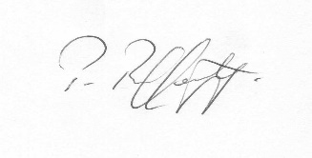
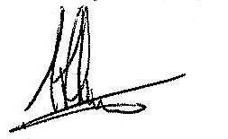
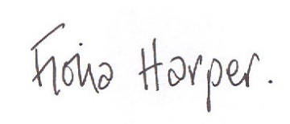
Fiona Harper  The Secretary | Pat Rafferty  For UNITE the Union | Alick Smith  For SELECT

