SJIB Circular 17/2021
17 December 2021

To all SJIB and SELECT Members

Dear Sir/Madam,
SJIB Fees from 31 January 2022
ECS Cards and ECS HSE Assessments

Please be advised that, at its meeting on 8 December 2021, the SJIB National Board agreed the following fees for implementation on 31 January 2022:

ECS Cards

Card Application Types | Fee from 31-01-2022
Initial | £40
Initial + Qualified Supervisor | £54
Renewal | £30
Renewal (Unite the Union) | £15
Upgrade | £30
Upgrade + Qualified Supervisor | £40
Replacement | £24
Pre-Apprentice | £10

ECS Health, Safety and Environmental Assessments

Groups | Fee from 31-01-2022
SELECT & SJIB Members | £42
Unite the Union Members | £42
Non- Members | £54
Self-Employed, Un-Employed, Agency Workers | £54

For more information on ECS cards and ECS Health, Safety and Environmental Assessments, please visit www.sjib.org.uk.

Yours faithfully,

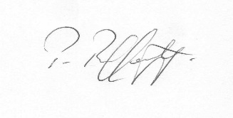
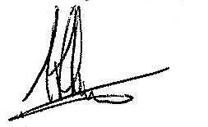
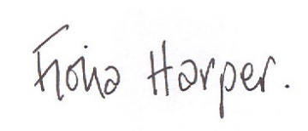
Fiona Harper  The Secretary | Pat Rafferty  For UNITE the Union | Alick Smith  For SELECT

