SJIB Circular 15/2021
26 November 2021

To all SJIB and SELECT Members

Dear Sir/Madam,
Revised Tool List
SJIB NWR Section B Appendix B7

The SJIB Tool List has been reviewed and updated.
The SJIB National Working Rules require that, all Apprentices and Adult Trainees purchase a set of hand tools throughout their training.
The majority of the tools required in Stage One are currently supplied to all Apprentices and Adult Trainees through a sponsorship agreement Edmundson Electrical and SECTT.
Apprentices, Adult Trainees and Operatives are responsible to ensure all tools are maintained to a good standard and replaced when necessary.
The revised Tool List is available from www.sjib.org.uk
Yours faithfully,
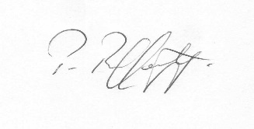
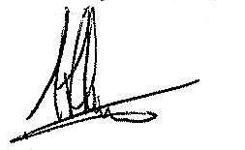
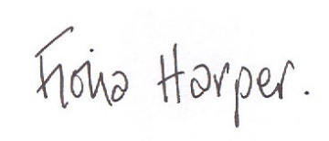
Fiona Harper  The Secretary | Pat Rafferty  For UNITE the Union | Alick Smith  For SELECT

SJIB Handbook - Section B – Appendix B7 - Tool List

1st Stage
Currently provided subject to sponsorship
C.K Magma MA2635 Technician Rucksack Plus
VDE Combination Pliers 205mm
VDE Side Cutters 180mm
VDE screwdriver – 150 x 3mm (parallel tip)
VDE screwdriver – 230 x 5mm (parallel tip)
VDE screwdriver – 200 x 4mm (parallel tip)
VDE screwdriver – 180mm (Cross-head)
VDE screwdriver – 220mm (Cross-head)
7.5m tape measure
Junior hacksaw
210mm spirit level
A current edition of BS 7671 – Requirements for Electrical Installations (IET Wiring Requirements).
A current edition of the IET On-Site Guide

Should get right away to add to bag
Hacksaw frame and blade (300mm blades)
Claw hammer (500g)

Apprentices to gain over first year
Longnose pliers
Wire Stripping tool
Electricians clasp knife
Heavy hammer 1.25 Kg
Flooring chisel (55mm)
Slip Joint Pliers
Try square (225mm)
Chalk line/laser level/Plumb bob and line

All tools to be insulated to the current IEC Standards to at least 1000V.

2nd Stage to 3rd Stage
Ratchet Crimping tool
Pad saw
Torque screwdriver – main boards.
Proprietary test lamp or 2-pole voltage detector, as recommended in HSE Guidance Note GS 38 Electrical Test Equipment for Use by Electricians.
Round file and handle (9mm second cut)
Flat file and handle (15mm second cut)

Depending on industry (Industrial, Commercial or Domestic)
Cold chisel (300mm x 20mm)
General purpose wood chisel (20mm)
Bar-type tap wrench (3-12mm)
Bush key spanner (20 and 25mm)
Multi-purpose saw (250 or 300mm)
Mole (curved jaw) grip wrench (250mm)
Centre punch (1.6mm)
Metric rule (300mm)
Set open-ended spanners (6-22mm)
20 mm/25 mm Flat Wood Bit

Note: - All tools should be maintained to a good standard and replaced when required.

