SJIB Circular 14/2021
26 November 2021

To all SELECT and SJIB Members

Dear Sir/Madam,

Changes to Statement of Employment Particulars

The SJIB recently conducted a review to update and modernise the following Statement of Employment Particulars for:

- Apprentices
- Adult Trainees
- Electrical Operatives

Employers must provide a principal statement on the first day of employment and a wider written statement within 2 months of the start of employment.

All Apprentices and Adult Trainees must be employed on SJIB Statement of Employment Particulars which are available from www.sjib.org.uk

For more guidance, please email fiona.cornwall@sjib.org.uk

Yours faithfully,

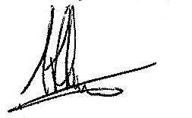
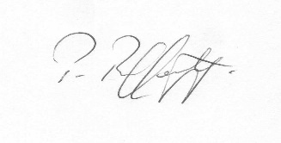
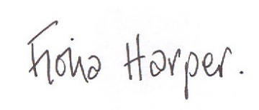
Fiona Harper  The Secretary | Pat Rafferty  For UNITE the Union | Alick Smith  For SELECT

