SJIB Circular 10/2021
25 June 2021

To all SJIB and SELECT Members

Dear Sir/Madam,

Change to the Apprentice & Adult Trainee Grading Timetable

Last year, as a result of COVID-19 and subsequent college closures, the SJIB National Board approved a temporary Grading Timetable to ease flow and completion.

Whilst things are easing in 2021 there is still a need to continue with the revised Grading Timetable.

The following timetable was approved by the SJIB National Board on Wednesday, 9 June 2021: -
- 3rd Monday in September (20 September)
- 3rd Monday in October (18 October)
- 3rd Monday in November (15 November)
- 3rd Monday in December (20 December)
- 3rd Monday in January 2022 (17 January)

These dates will enable the up-grading of Apprentices/Adult Trainees at the first available opportunity following completion of the required coursework and practical experience.

Members wishing further information should email fiona.cornwall@sjib.org.uk.

Yours faithfully,
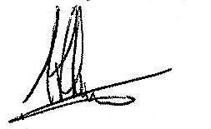
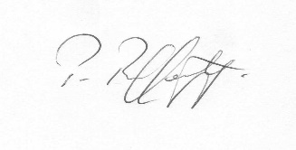
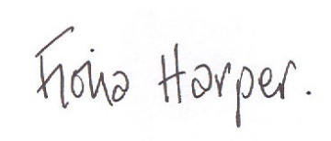
Fiona Harper  The Secretary | Pat Rafferty  For UNITE the Union | Alick Smith  For SELECT

