SJIB Circular 09/2021
25 June 2021

To all SJIB and SELECT Members

Dear Sir/Madam,

Change to National Working Rule (NWR) E.5.5(b)
Permanent and Total Disability Benefit

At its meeting on Wednesday, 9 June 2020, the SJIB National Board agreed that National Working Rule (NWR) E5.5(b) would change with immediate effect and that the current wording would be replaced with the following: -

Where an Operative suffers some other serious illness or injury other than that specified above and if, as a result of such illness or injury, the Operative is unable to ever work in the future in his SJIB Grade, the Operative is recommended to contact the Electrical Industries Charity at www.electricalcharity.org. Union members may also contact Unite the Union’s Benevolent Fund at Unite Benevolent Fund, Member Benefits - Unite The Union.

Members wishing further information should email michelle.courtney@sjib.org.uk.

Yours faithfully,
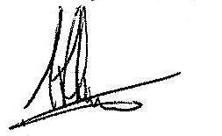
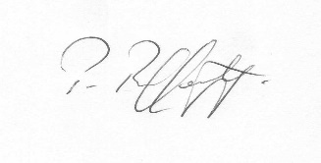
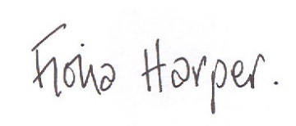
Fiona Harper  The Secretary | Pat Rafferty  For UNITE the Union | Alick Smith  For SELECT

