SJIB Circular 04/2020
31 August 2020

To all SELECT and SJIB Members

Dear Sir/Madam,

SJIB Apprentice Training Scheme
Termination of Apprenticeship through Redundancy

One of the objectives of the SJIB Training Scheme for Electrical Installation Apprentices is to guarantee training to completion of apprenticeship. However, as the effects of the COVID-19 pandemic bite deeper, the SJIB and SECTT have seen an increase in the number of apprentices being made redundant. The SJIB National Board understands that in these uncertain times difficult decisions have to be made and companies may feel they have no alternative but to make apprentices redundant. In this instance companies must follow the guidelines agreed by the National Board which are detailed in the National Working Rules, Section J - SJIB Apprentice and Adult Training Schemes Guide.

Before making any apprentice redundant, employers must complete and return a “Request for Dismissal through Redundancy” form to the Secretary of the SJIB and apply for dispensation prior to the effective date of redundancy.

An employer should only dismiss an apprentice as redundant if the dismissal has been agreed by The SJIB Secretary.

If an apprentice has been made redundant the SJIB will work with SECTT to provide support, helping them secure alternative employment or see them through to completing their FICA.

Members wishing further information should contact the SJIB at the Walled Garden on 0131 445 9216 or email fiona.cornwall@sjib.org.uk.

Yours faithfully,

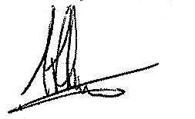
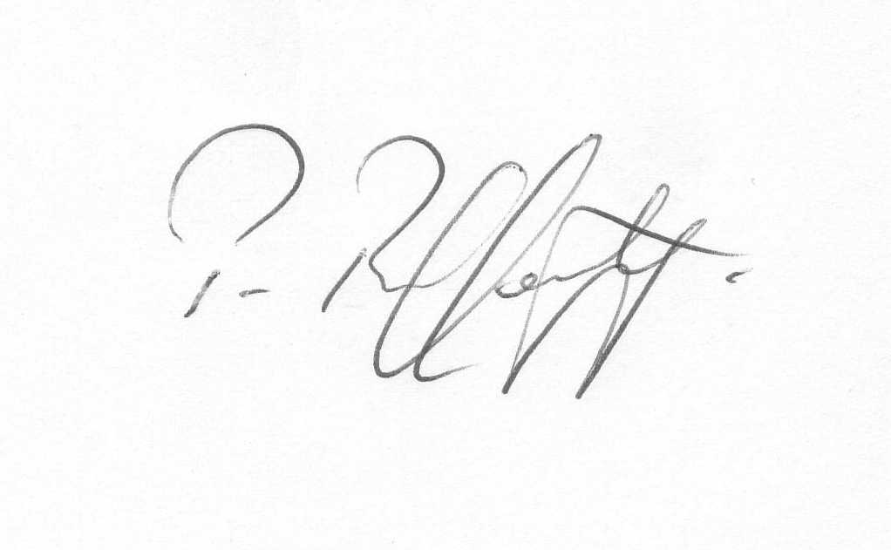
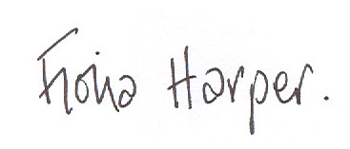

Fiona Harper Pat Rafferty Alick Smith
The Secretary For UNITE the Union For SELECT

Request for Dismissal through Redundancy
(One form per Apprentice)

Company Name:

Address:

Contact:

Contact Number:

Postcode

Apprentice Name:

N.I. Number: D.O.B.:

Stage: (1, 2 or 3) Start Date with Company:

Training Officer:

Reason for Redundancy (continue on a separate sheet if required)

Proposed Date:

N.B: An employer can only dismiss and Apprentice as redundant
if the dismissal is agreed by the SJIB Secretary

Return to: fiona.cornwall@select.org.uk

