SJIB Circular 05/2021
26 March 2021

To all SELECT and SJIB Members

Dear Sir/Madam,

New SJIB On-Line Application Portal
for ECS Cards

Throughout Lockdown, the SJIB has been transferring its database onto a new information management system.

The system will be launched in the Spring meaning that applications for ECS cards can be made online through a new portal.

The new ECS Cards section will be broken down into the following key specialist areas:

- Electrotechnical
- Management
- Network Infrastructure (originally Datacomms)
- Fire, Emergency & Security Systems (FESS)
- Cabling and Jointing
- Building Controls

Applicants will be able to select their specialism and a list of different cards will appear. When they select a card, a unique summary of the criteria will appear detailing the requirements that must be met to either obtain a card for the first time, to renew a card or, where applicable, upgrade to the next level.

Applicants are advised to click on the appropriate on-line application, and they will be asked to complete various sections, some mandatory, others optional. In addition, they will be asked to enter the dates on which they completed specific training and upload copies of relevant certificates.

Please note that Applicants will be unable to proceed if they fail to enter dates and/or upload certificates.

In addition, some Applicants may have to organise specific training before they can complete the on-line application.
The final stage of the process requires Applicants to pay the relevant fee and once they hit the ‘Finish’ button, the application will appear in the SJIB Administrators’ To Do Lists for processing.

At this stage, Applicants will be advised that the SJIB will review their application. They will also be advised of any issues that may cause delay to the production and issue of their card.

We have strived to make the on-line application process as a straightforward as possible. Nevertheless, we understand that completing an on-line application for the first time can be daunting. We also acknowledge that some Applicants may not have access to a mobile or a computer and would prefer to complete a paper-based application. It will, therefore, still be possible to download and print a paper version. All completed paper applications must be posted to the Walled Garden.

We are launching the cards in stages. Our initial focus will be on the cards that fall under the Electrotechnical, ECS Related Discipline and Management specialisms. Others will follow in due course.

Yours faithfully,
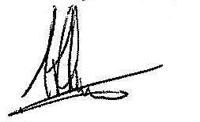
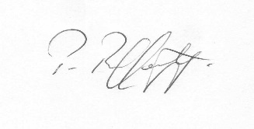
Fiona Harper  The Secretary | Pat Rafferty  For UNITE the Union | Alick Smith  For SELECT

